Pig Projects

1. Finding Maximum lengthed Road out of all roads

road = LOAD '/home/hadoop/Desktop/DataSet/StateUTlengthHighways/brs2012tab2.1.csv' USING PigStorage(',') AS (name:chararray,lengh:int);

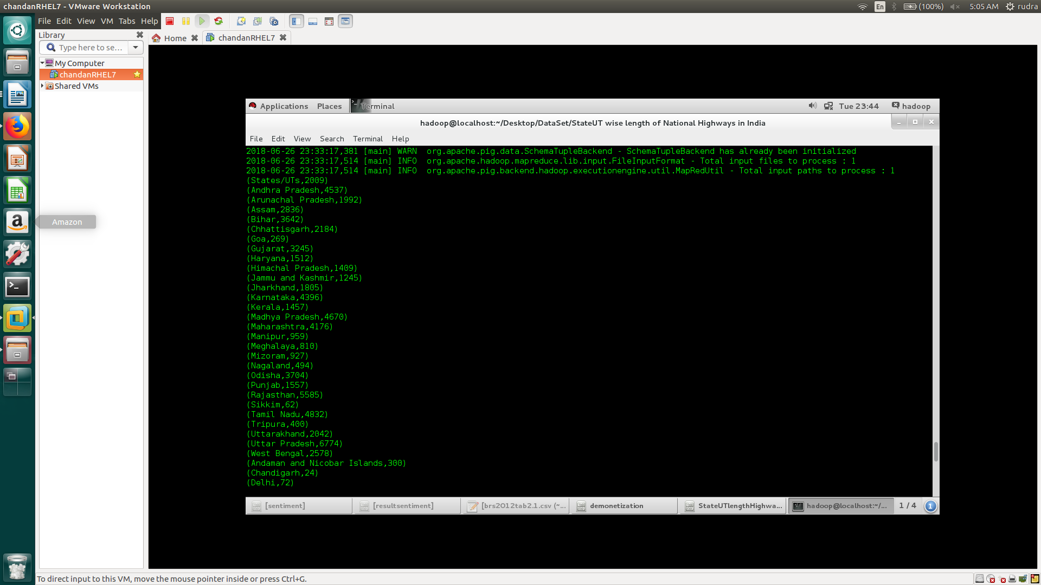

grouproad = Group road All;

maxlengh = foreach road GENERATE (road.name, MAX(road.lengh));
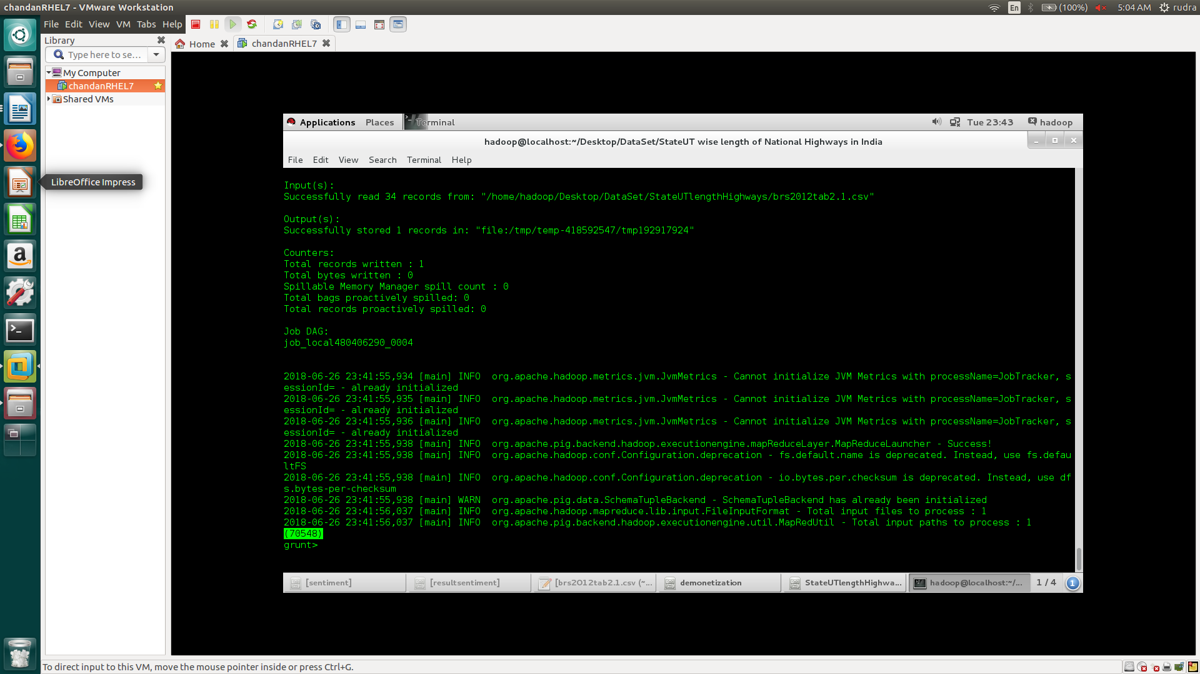

2. To get the list of sorted distance from various stations

Step1: Load the details from the given data(file)

train_details = LOAD '/home/hadoop/Desktop/DataSet/IndianRailways/isl_wise_train.csv' USING PigStorage(',') AS (trainNo:chararray,trainName:chararray,islno:int,stationCode:chararray,stationName:chararray,arrivalTime:chararray,departureTime:chararray,distance:long,sourceStationCode:chararray,sourceStationName:chararray,destinationStationCode:chararray,destinationStationName:chararray);

Step2: Grouping the loaded data to box to perform various grouping operations.

A = GROUP train_details BY trainName;

Step3: Using FOREACH ... GENERATE operation to sort the list by descending order of the distances travelled by train.

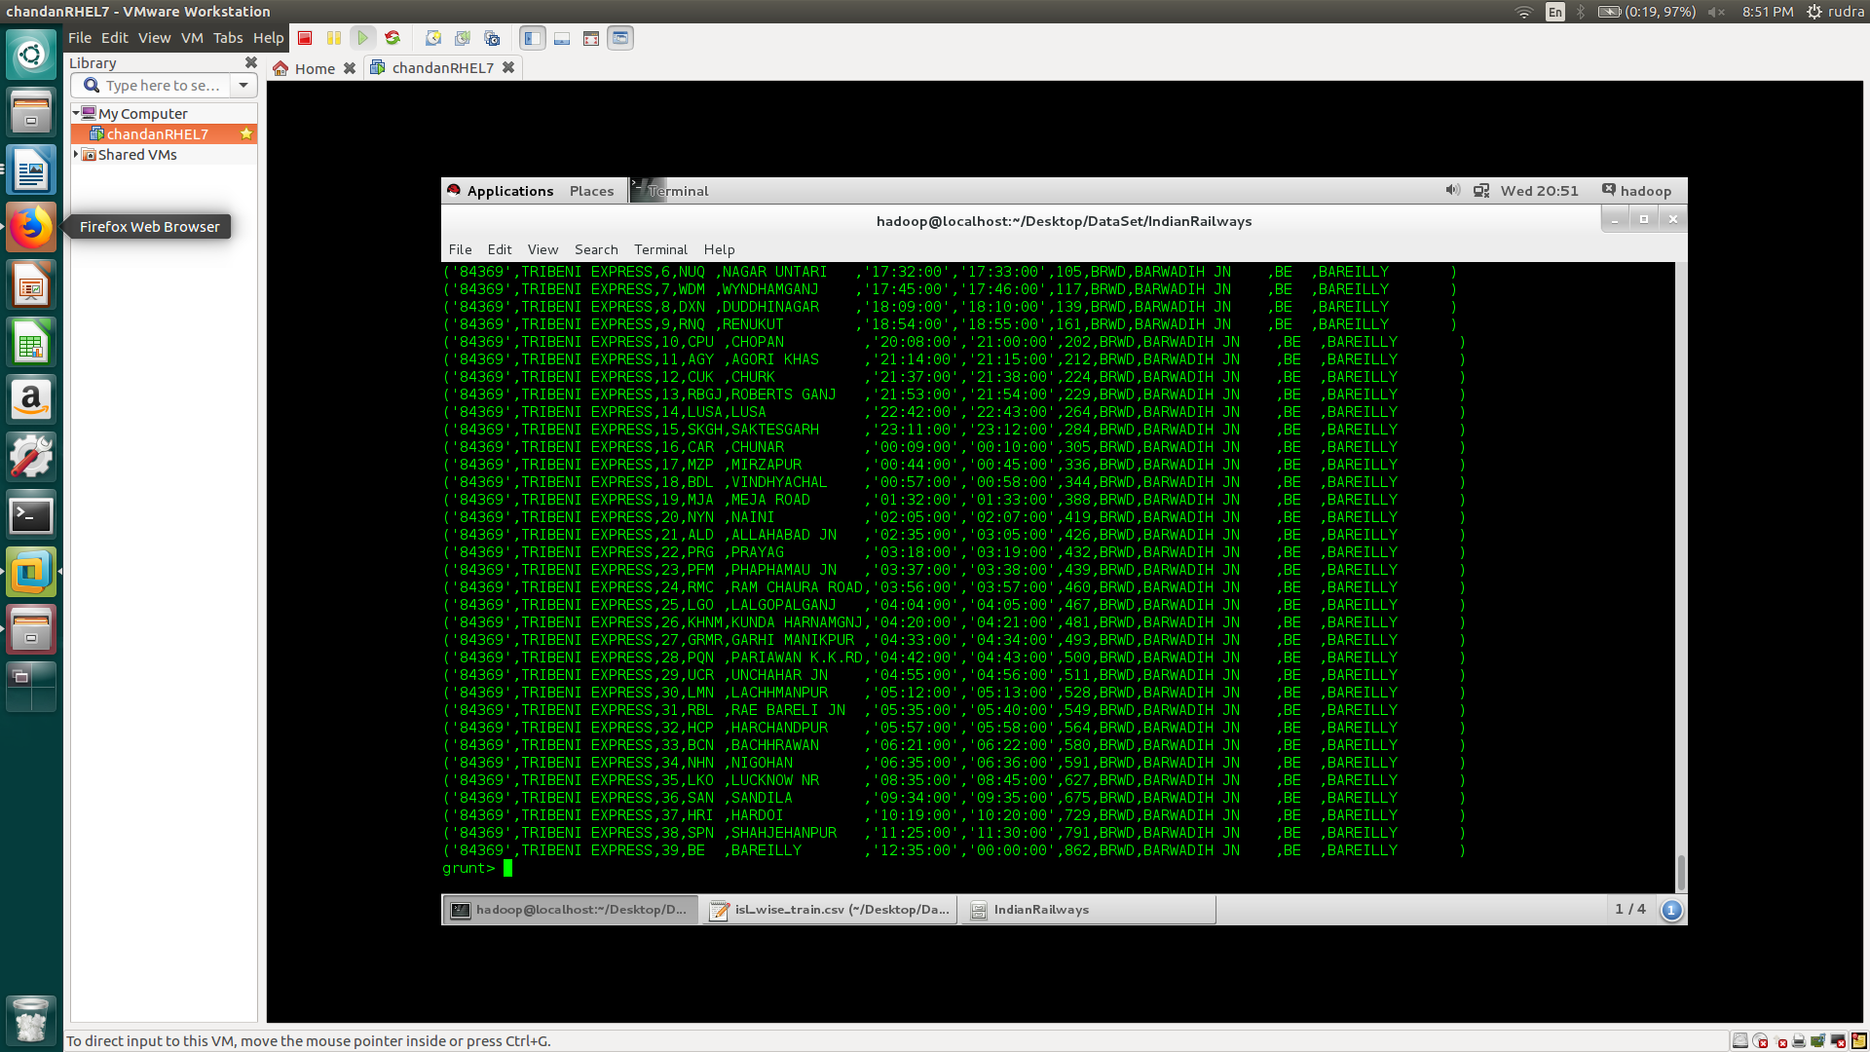

dest = FOREACH A {
sorted = order train_list by distance desc}
top = limit sorted 1;
generate flatten(top);
};

Step4: Generating the list of train with attributes such as train number, train name, destination station etc.

B = FOREACH dest GENERATE trainNo,trainName,sourceStationName,destinationStationName,distance;

dump

And, Finally performing dump operation to show the results.
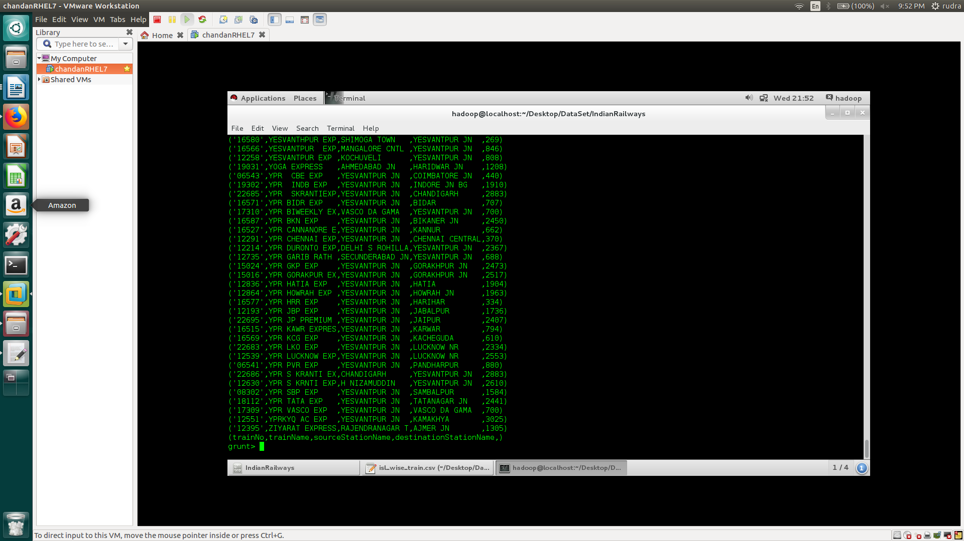

3. To Find rhe Maximum distance travelled by trains having same islno.

Step1: Load the details from the given data(file)

train_details = LOAD '/home/hadoop/Desktop/DataSet/IndianRailways/isl_wise_train.csv' USING PigStorage(',') AS (trainNo:chararray,trainName:chararray,islno:int,stationCode:chararray,stationName:chararray,arrivalTime:chararray,departureTime:chararray,distance:long,sourceStationCode:chararray,sourceStationName:chararray,destinationStationCode:chararray,destinationStationName:chararray);

Step2: Filtering the trains on the basis of islno.

A = FILTER train_details BY islno == 1;

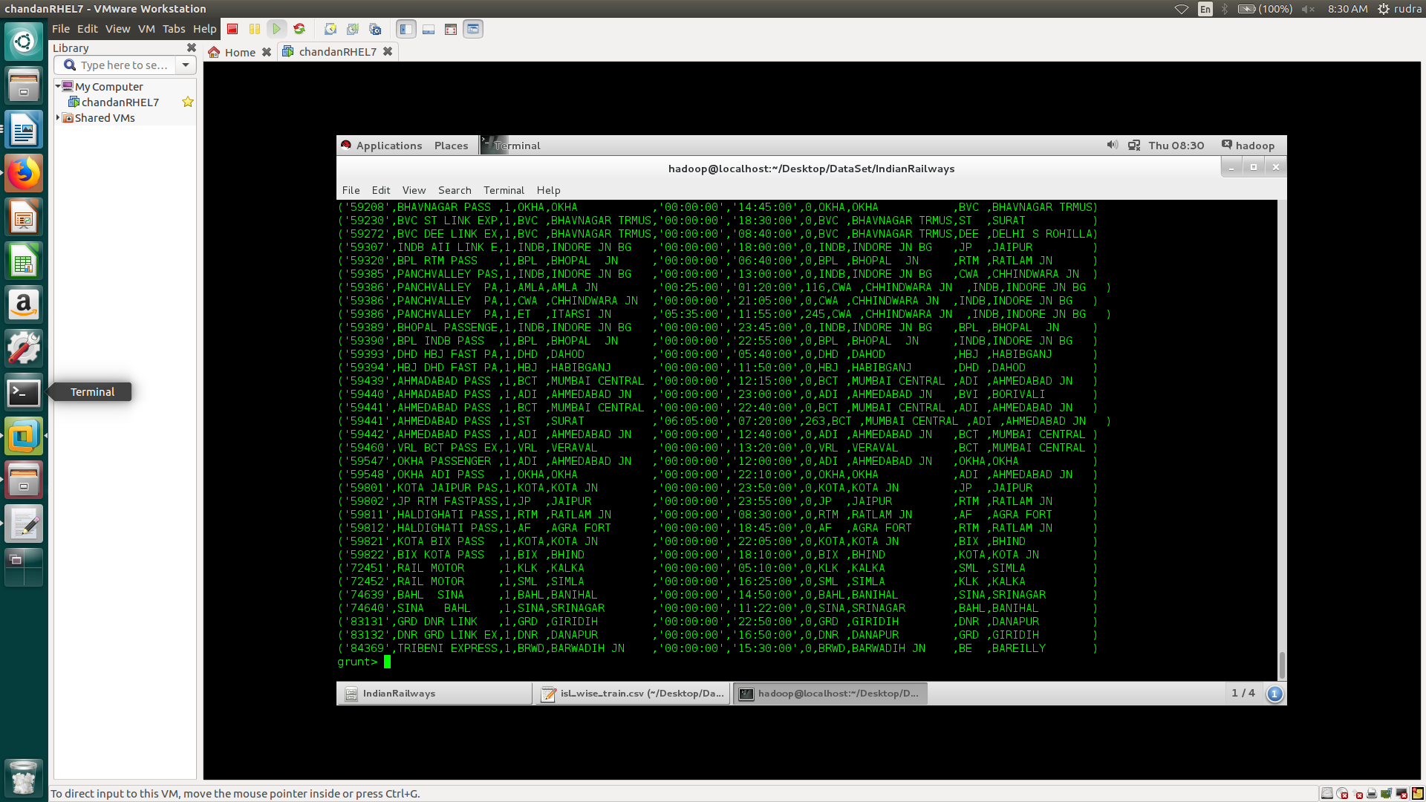

Step3: Sorting the same islno. Trains with respect to distance travelled

B = ORDER A BY distance desc;

Step4: Grouping the same islno. Trains to perform grouping operations.
C = GROUP B All;

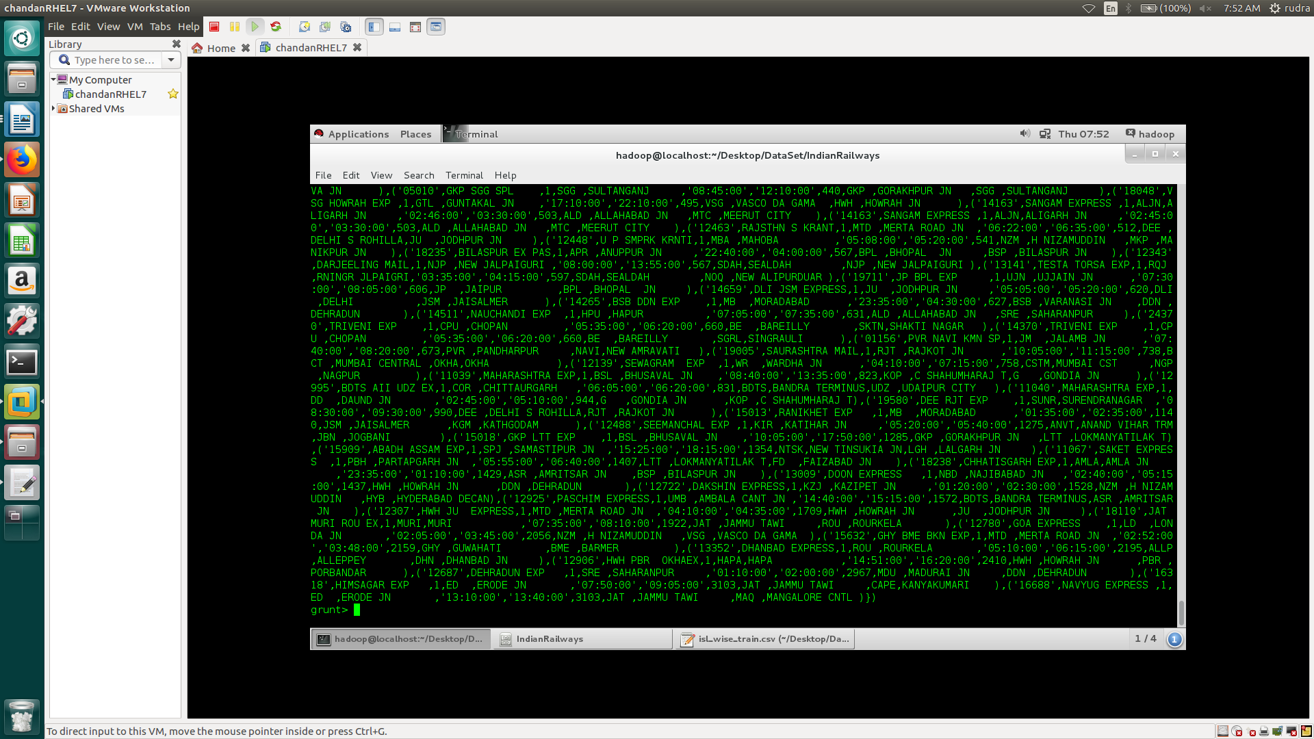

Step5: Finding the overall maximum distance travelled by the same islno trains.
D = FOREACH C GENERATE MAX(B.distance);

Step6: dump to show the result.
DUMP

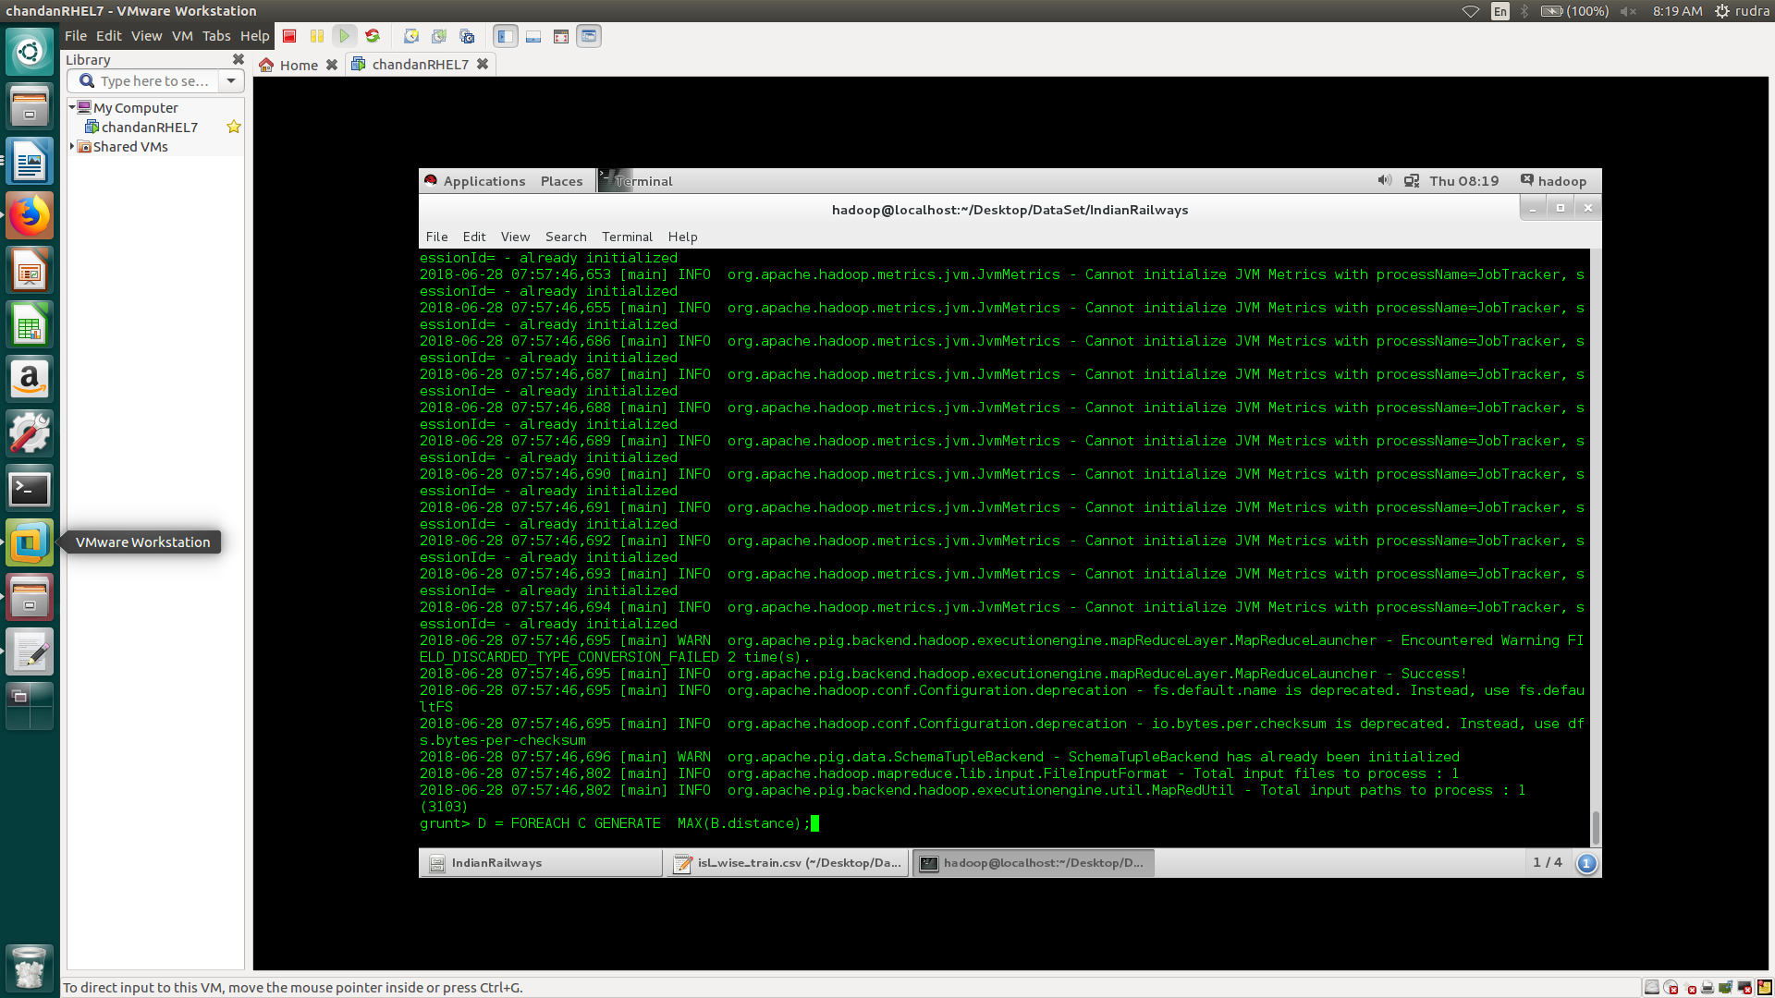

4. Trains going from one particular station to another having distance lesser than 50KM.

train_details = LOAD '/home/hadoop/Desktop/DataSet/IndianRailways/isl_wise_train.csv' USING PigStorage(',') AS (trainNo:chararray,trainName:chararray,islno:int,stationCode:chararray,stationName:chararray,arrivalTime:chararray,departureTime:chararray,distance:long,sourceStationCode:chararray,sourceStationName:chararray,destinationStationCode:chararray,destinationStationName:chararray);

A = FILTER train_details BY islno == 2;

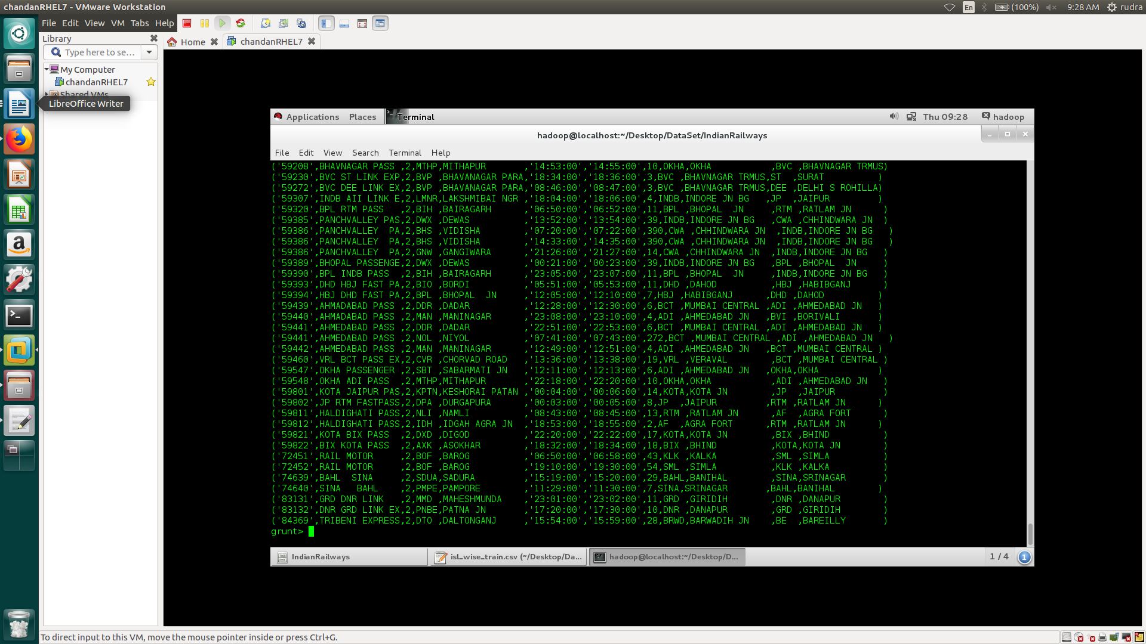

B = FOREACH A GENERATE trainNo,trainName,sourceStationCode,destinationStationCode,distance;

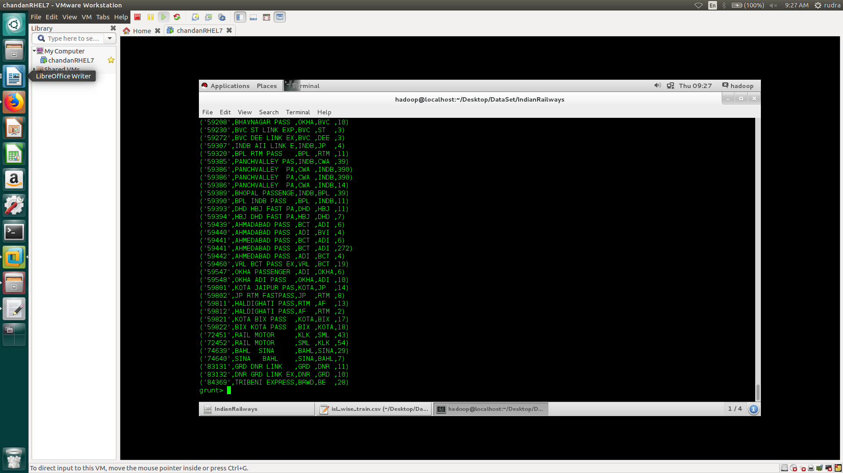

C = FILTER B BY sourceStationCode == 'KOTA';

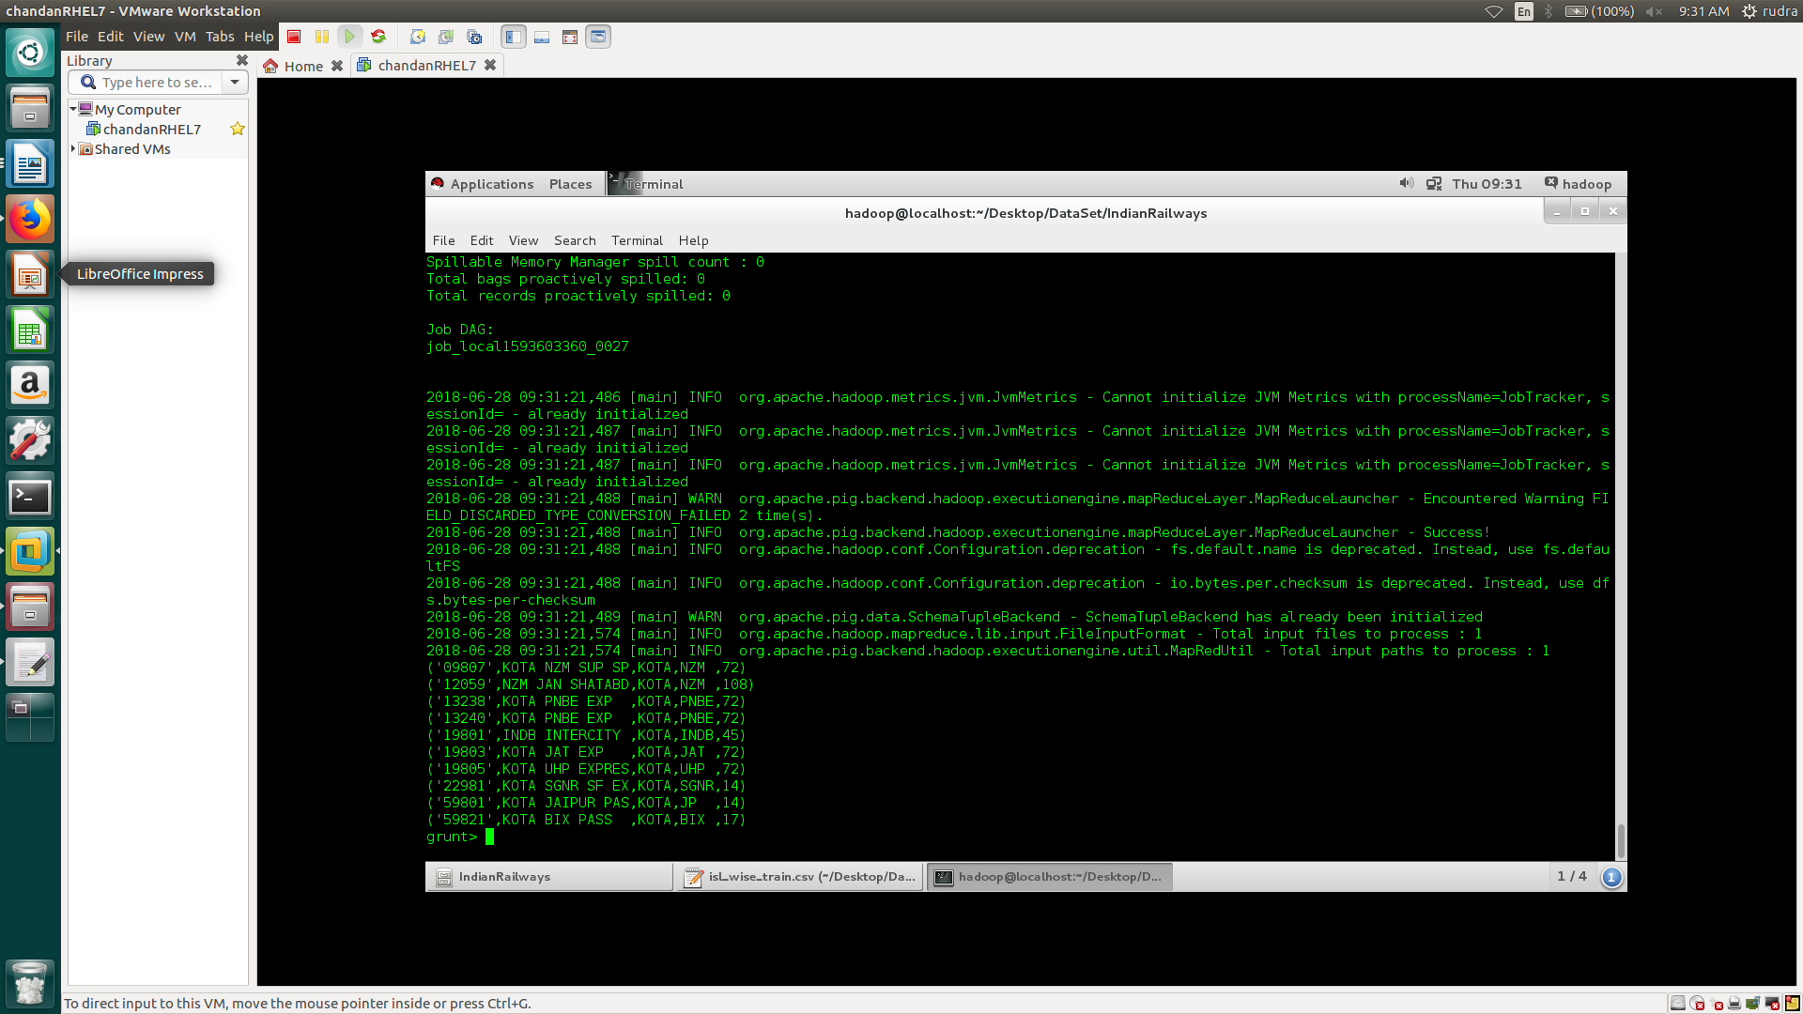

D = FILTER C BY distance < 50;

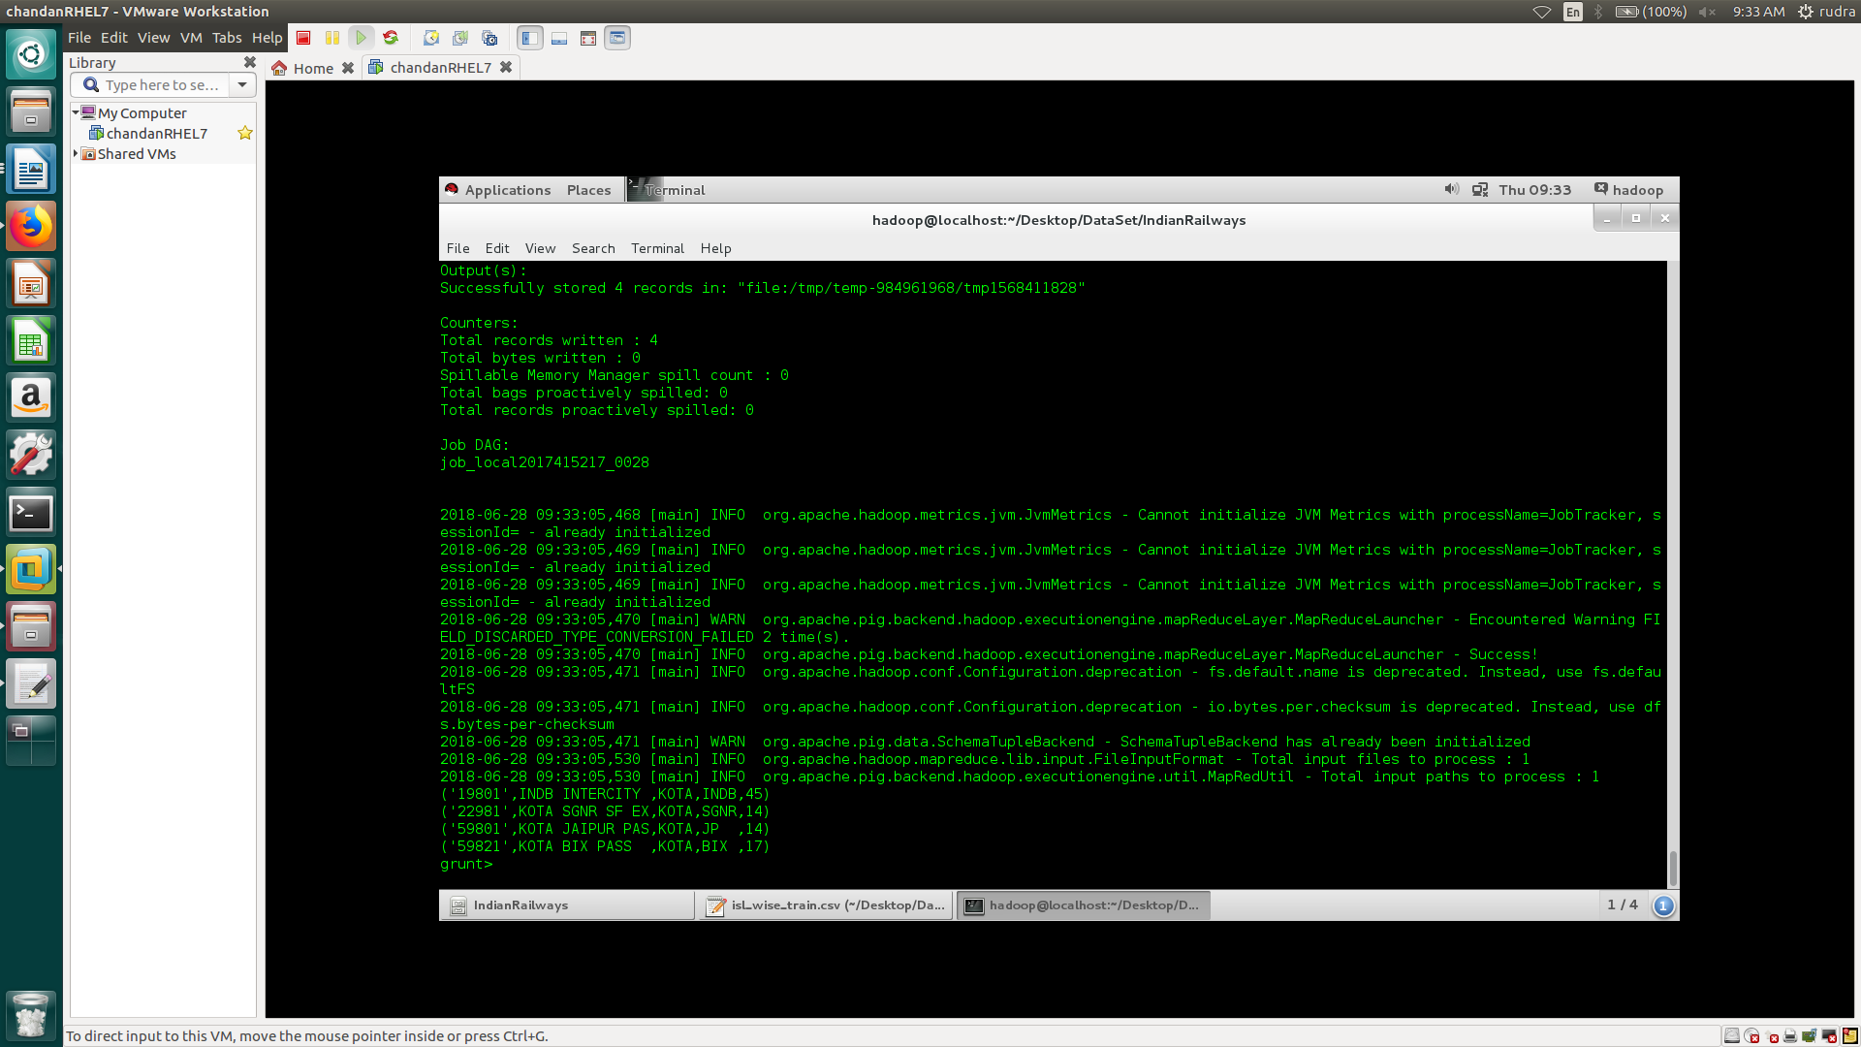

5. Trains starting from one particular source station and goes to a pariticular station.

train_details = LOAD '/home/hadoop/Desktop/DataSet/IndianRailways/isl_wise_train.csv' USING PigStorage(',') AS (trainNo:chararray,trainName:chararray,islno:int,stationCode:chararray,stationName:chararray,arrivalTime:chararray,departureTime:chararray,distance:long,sourceStationCode:chararray,sourceStationName:chararray,destinationStationCode:chararray,destinationStationName:chararray);

A = FOREACH traine_details GENERATE trainName, stationCode, departureTime, sourceStationCode, destinationStationCode;

B = FILTER A BY sourceStationCode = 'BPL ';

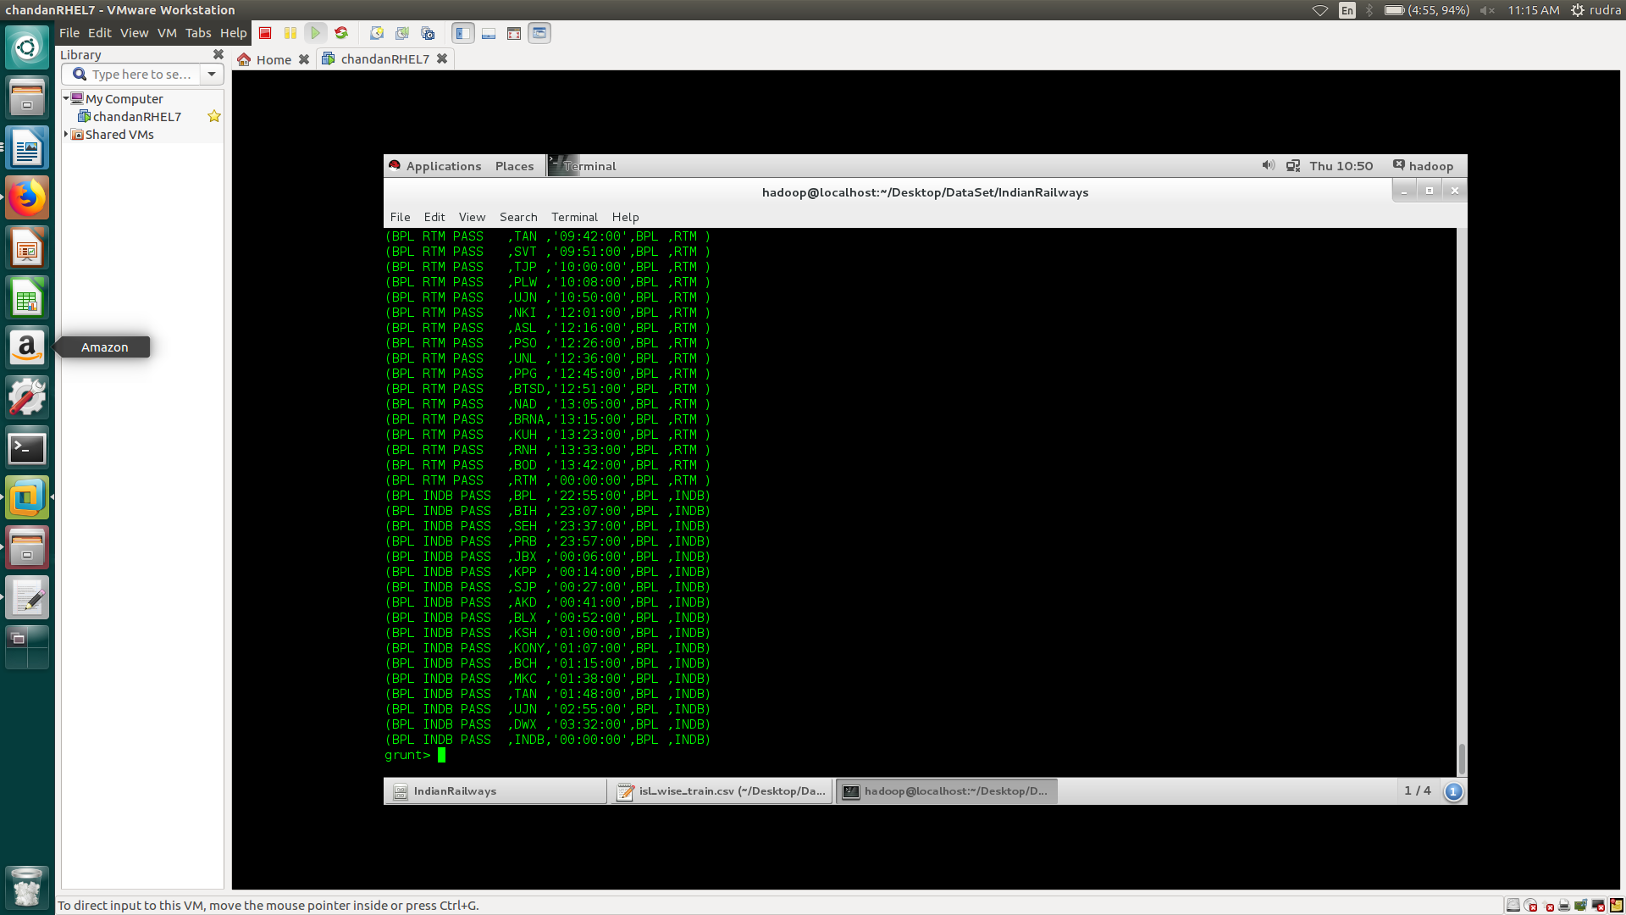

C = FILTER B BY destinationStationCode == 'INDB';

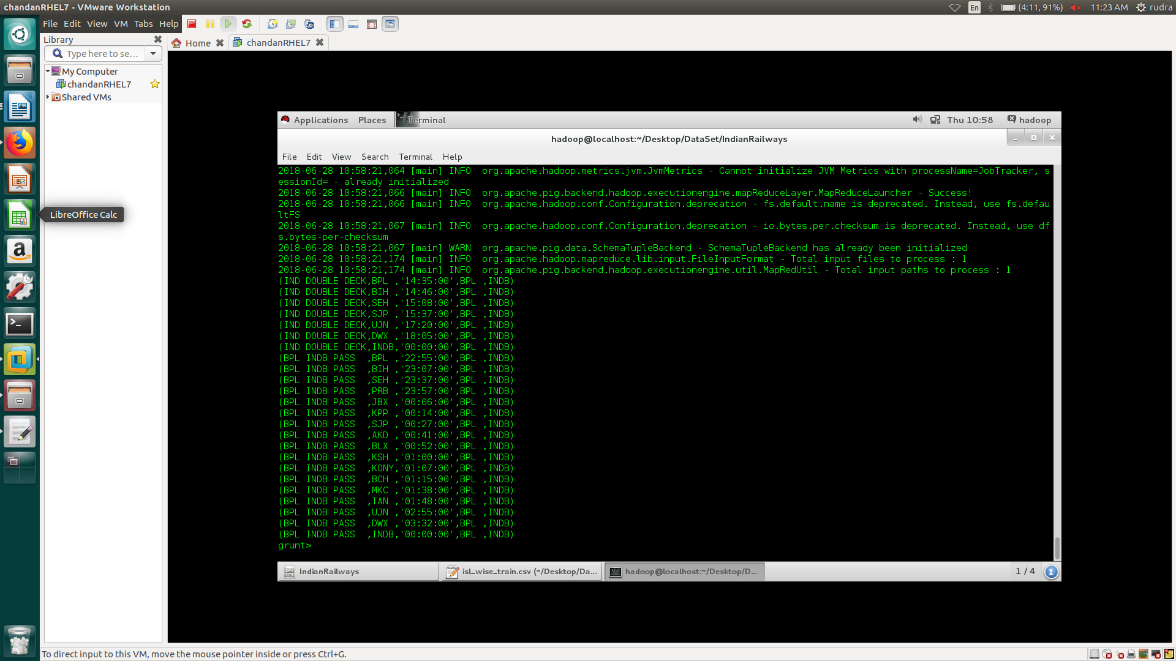

D = FILTER C BY stationCode == 'BPL ';

